Accessibility Audit Report

Target URL: https://nems.org/

Methodology: axe-core baseline + semantic review (RAG).

# Overview

|  |  |  |  |
| --- | --- | --- | --- |
| Bucket | Count | AI Candidates | AI Verdicts |
| Violations | 6 |  |  |
| Incomplete | 2 |  |  |
| Passes | 38 |  |  |
| AI Candidates | 78 |  |  |
| AI Verdicts | 78 |  |  |

# Findings (AI verdicts)

## 1. SC-4.1.2 — aria-hidden-focus

Selector: #access_container

Verdict: needs-change (confidence 0.9)

Reason: The element has aria-hidden='true' but is focusable, violating SC 4.1.2. Focusable elements should not be hidden from accessibility tools.

Ref: https://dequeuniversity.com/rules/axe/4.7/aria-hidden-focus?application=axeAPI

Screenshot:



Open full-size image

## 2. SC-1.4.3 — color-contrast

Selector: .active.owl-item:nth-child(1) > .locitem.item > .locitem-inner > .lci-content > .lci-area

Verdict: needs-change (confidence 0.9)

Reason: Computed contrast ratio is 3.06, below the required 4.5:1 for normal text, indicating insufficient contrast for readability.

Ref: https://dequeuniversity.com/rules/axe/4.7/color-contrast?application=axeAPI

Screenshot:



Open full-size image

## 3. SC-1.4.3 — color-contrast

Selector: .active.owl-item:nth-child(1) > .locitem.item > .locitem-inner > .lci-content > .lci-hours > .lci-hourstitle

Verdict: needs-change (confidence 0.9)

Reason: Computed contrast ratio is 3.06, below the required 4.5:1 for normal text, indicating insufficient contrast for 'Clinic Hours'.

Ref: https://dequeuniversity.com/rules/axe/4.7/color-contrast?application=axeAPI

Screenshot:



Open full-size image

## 4. SC-1.4.3 — color-contrast

Selector: .active.owl-item:nth-child(2) > .locitem.item > .locitem-inner > .lci-content > .lci-area

Verdict: needs-change (confidence 0.9)

Reason: Computed contrast ratio is 3.06, below the required 4.5:1 for normal text. This violates SC 1.4.3 requirements.

Ref: https://dequeuniversity.com/rules/axe/4.7/color-contrast?application=axeAPI

Screenshot:



Open full-size image

## 5. SC-1.4.3 — color-contrast

Selector: .active.owl-item:nth-child(2) > .locitem.item > .locitem-inner > .lci-content > .lci-hours > .lci-hourstitle

Verdict: needs-change (confidence 0.9)

Reason: Computed contrast ratio is 3.06, below the required 4.5:1 for normal text. This violates SC 1.4.3.

Ref: https://dequeuniversity.com/rules/axe/4.7/color-contrast?application=axeAPI

Screenshot:



Open full-size image

## 6. SC-1.4.3 — color-contrast

Selector: .active.owl-item:nth-child(3) > .locitem.item > .locitem-inner > .lci-content > .lci-area

Verdict: needs-change (confidence 0.9)

Reason: Computed contrast is 3.06, below the required 4.5:1 for normal text. This violates SC 1.4.3.

Ref: https://dequeuniversity.com/rules/axe/4.7/color-contrast?application=axeAPI

Screenshot:



Open full-size image

## 7. SC-1.4.3 — color-contrast

Selector: .active.owl-item:nth-child(3) > .locitem.item > .locitem-inner > .lci-content > .lci-hours > .lci-hourstitle

Verdict: needs-change (confidence 0.9)

Reason: Computed contrast ratio is 3.06, below the required 4.5:1 for normal text. This violates SC 1.4.3.

Ref: https://dequeuniversity.com/rules/axe/4.7/color-contrast?application=axeAPI

Screenshot:



Open full-size image

## 8. BEST_PRACTICE — heading-order

Selector: .homeabout-content > h5

Verdict: needs-change (confidence 0.8)

Reason: The heading order is invalid as per axe diagnostics, indicating a need for adjustment in heading levels.

Ref: https://dequeuniversity.com/rules/axe/4.7/heading-order?application=axeAPI

Screenshot:



Open full-size image

## 9. BEST_PRACTICE — heading-order

Selector: .quotes-intro > h5

Verdict: needs-change (confidence 0.8)

Reason: The heading order is invalid as per axe diagnostics, indicating a need for adjustment in heading levels.

Ref: https://dequeuniversity.com/rules/axe/4.7/heading-order?application=axeAPI

Screenshot:



Open full-size image

## 10. BEST_PRACTICE — landmark-one-main

Selector: html

Verdict: needs-change (confidence 0.8)

Reason: The document lacks a main landmark, which is essential for accessibility. This violates the guideline for having a clear main content area.

Ref: https://dequeuniversity.com/rules/axe/4.7/landmark-one-main?application=axeAPI

Screenshot:

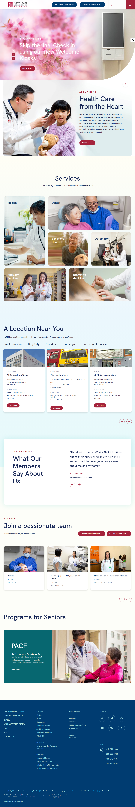

Open full-size image

## 11. SC-4.1.2 — link-name

Selector: .btn-menu

Verdict: needs-change (confidence 0.9)

Reason: The element has no discernible text or accessible name, violating SC 4.1.2. It is in tab order but lacks an aria-label or visible text.

Ref: https://dequeuniversity.com/rules/axe/4.7/link-name?application=axeAPI

Screenshot:



Open full-size image

## 12. BEST_PRACTICE — region

Selector: #hbslides > .owl-stage-outer

Verdict: needs-change (confidence 0.8)

Reason: The element lacks a defined role and is not contained by landmarks, which violates the requirement for all page content to be contained by landmarks.

Ref: https://dequeuniversity.com/rules/axe/4.7/region?application=axeAPI

Screenshot:

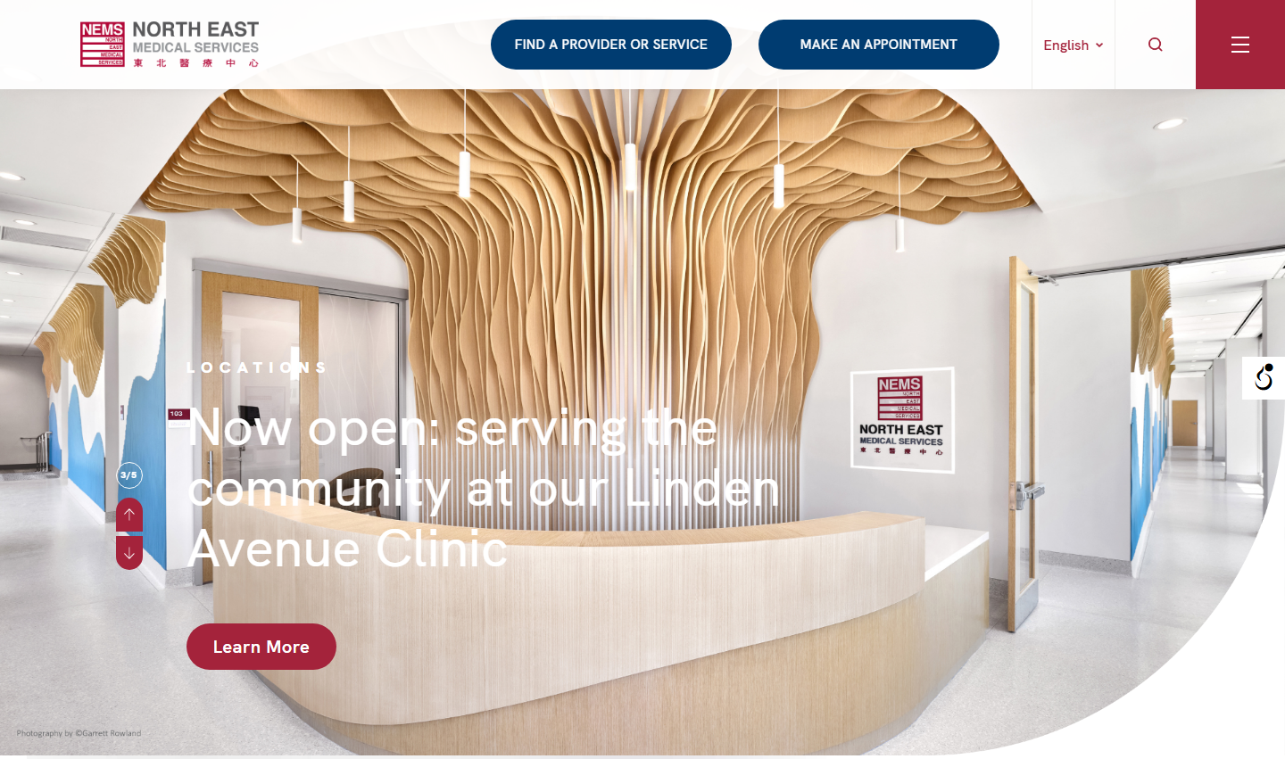

Open full-size image

## 13. BEST_PRACTICE — region

Selector: #counter

Verdict: needs-change (confidence 0.8)

Reason: The element lacks a landmark role, which is necessary for accessibility. It does not provide a clear programmatic name or context, failing to meet SC 4.1.2.

Ref: https://dequeuniversity.com/rules/axe/4.7/region?application=axeAPI

Screenshot:



Open full-size image

## 14. BEST_PRACTICE — region

Selector: .hbcurve

Verdict: needs-change (confidence 0.8)

Reason: The alt attribute is empty, failing to provide context for the image, which is likely informative given the nearby text 'LOCATIONS'.

Ref: https://dequeuniversity.com/rules/axe/4.7/region?application=axeAPI

Screenshot:

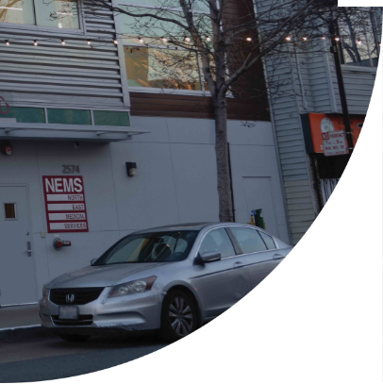

Open full-size image

## 15. BEST_PRACTICE — region

Selector: #home-about

Verdict: needs-change (confidence 0.8)

Reason: The section lacks a landmark role, which is necessary for accessibility. All page content should be contained by landmarks as per axe guidance.

Ref: https://dequeuniversity.com/rules/axe/4.7/region?application=axeAPI

Screenshot:



Open full-size image

## 16. BEST_PRACTICE — region

Selector: .hs-intro

Verdict: needs-change (confidence 0.8)

Reason: The content is not contained by landmarks, which violates the axe rule for regions. The div lacks a proper role or landmark designation.

Ref: https://dequeuniversity.com/rules/axe/4.7/region?application=axeAPI

Screenshot:



Open full-size image

## 17. BEST_PRACTICE — region

Selector: .hs-desktop

Verdict: needs-change (confidence 0.8)

Reason: The div with class 'hs-desktop' lacks a landmark role, causing some content to be uncontained by landmarks, violating accessibility guidelines.

Ref: https://dequeuniversity.com/rules/axe/4.7/region?application=axeAPI

Screenshot:



Open full-size image

## 18. BEST_PRACTICE — region

Selector: #homelocations > .basic

Verdict: needs-change (confidence 0.8)

Reason: The content is not contained by landmarks, which violates the axe rule for region. This affects navigation and accessibility for users relying on assistive technologies.

Ref: https://dequeuniversity.com/rules/axe/4.7/region?application=axeAPI

Screenshot:



Open full-size image

## 19. BEST_PRACTICE — region

Selector: #sfslides > .owl-stage-outer

Verdict: needs-change (confidence 0.8)

Reason: The element lacks a landmark role, causing some content to be uncontained by landmarks, which violates accessibility standards.

Ref: https://dequeuniversity.com/rules/axe/4.7/region?application=axeAPI

Screenshot:

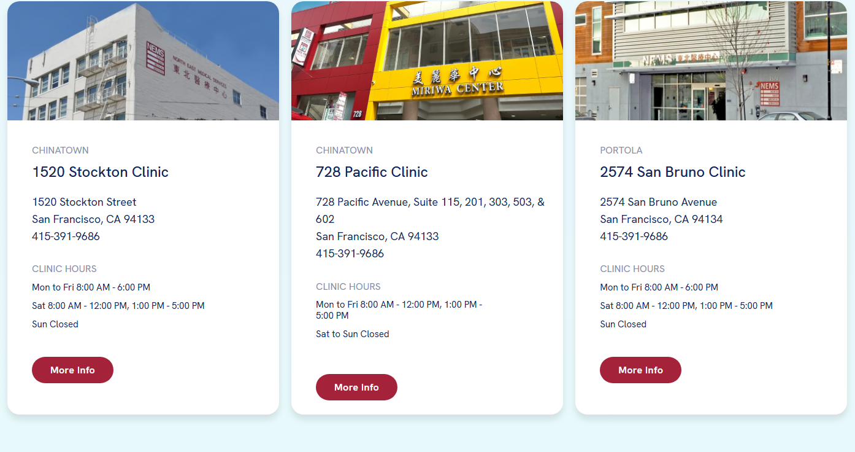

Open full-size image

## 20. BEST_PRACTICE — region

Selector: .quotes-intro

Verdict: needs-change (confidence 0.8)

Reason: The content is not contained by landmarks, which violates the axe rule for region. The div lacks a proper role or landmark designation.

Ref: https://dequeuniversity.com/rules/axe/4.7/region?application=axeAPI

Screenshot:



Open full-size image

## 21. BEST_PRACTICE — region

Selector: #quoteslides > .owl-stage-outer

Verdict: needs-change (confidence 0.8)

Reason: The element lacks a landmark role, causing some content to be outside of landmarks, which violates SC 4.1.2. It needs a proper role to ensure accessibility.

Ref: https://dequeuniversity.com/rules/axe/4.7/region?application=axeAPI

Screenshot:

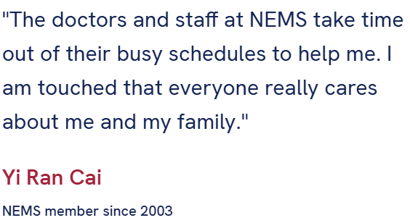

Open full-size image

## 22. BEST_PRACTICE — region

Selector: #careers > .basic:nth-child(1)

Verdict: needs-change (confidence 0.8)

Reason: The div lacks a landmark role, causing content to not be contained by landmarks, violating axe:region guidance.

Ref: https://dequeuniversity.com/rules/axe/4.7/region?application=axeAPI

Screenshot:



Open full-size image

## 23. BEST_PRACTICE — region

Selector: #careerslides > .owl-stage-outer

Verdict: needs-change (confidence 0.8)

Reason: The element lacks a landmark role, causing some content to be uncontained, which violates the axe rule for regions.

Ref: https://dequeuniversity.com/rules/axe/4.7/region?application=axeAPI

Screenshot:



Open full-size image

## 24. BEST_PRACTICE — region

Selector: #seniors

Verdict: needs-change (confidence 0.8)

Reason: The section with id 'seniors' lacks a landmark role, causing some content to be outside of landmarks, violating SC 2.4.1.

Ref: https://dequeuniversity.com/rules/axe/4.7/region?application=axeAPI

Screenshot:



Open full-size image

## 25. BEST_PRACTICE — region

Selector: #scrollup

Verdict: needs-change (confidence 0.8)

Reason: The alt text 'Up' is vague and does not clearly communicate the action or target of the image, which is meant to scroll up. This violates SC 1.1.1.

Ref: https://dequeuniversity.com/rules/axe/4.7/region?application=axeAPI

Screenshot:



Open full-size image

## 26. BEST_PRACTICE — aria-allowed-role

Selector: #hbslides > .owl-nav.disabled > .owl-prev[role="presentation"][type="button"]

Verdict: needs-change (confidence 0.9)

Reason: The role 'presentation' is inappropriate for a button element, which must have a functional role. This violates the aria-allowed-role guideline.

Ref: https://dequeuniversity.com/rules/axe/4.7/aria-allowed-role?application=axeAPI

Screenshot:

(Could not embed image: — [Errno 13] Permission denied: '.')

Open full-size image

## 27. BEST_PRACTICE — aria-allowed-role

Selector: #hbslides > .owl-nav.disabled > .owl-next[role="presentation"][type="button"]

Verdict: needs-change (confidence 0.9)

Reason: The role 'presentation' is inappropriate for a button that is functional; it must be removed as per axe diagnostics.

Ref: https://dequeuniversity.com/rules/axe/4.7/aria-allowed-role?application=axeAPI

Screenshot:

(Could not embed image: — [Errno 13] Permission denied: '.')

Open full-size image

## 28. BEST_PRACTICE — aria-allowed-role

Selector: #sfslides > .owl-nav.disabled > .owl-prev[role="presentation"][type="button"]

Verdict: needs-change (confidence 0.9)

Reason: The role 'presentation' is inappropriate for a button that is functional; it must be removed to comply with ARIA role requirements.

Ref: https://dequeuniversity.com/rules/axe/4.7/aria-allowed-role?application=axeAPI

Screenshot:

(Could not embed image: — [Errno 13] Permission denied: '.')

Open full-size image

## 29. BEST_PRACTICE — aria-allowed-role

Selector: #sfslides > .owl-nav.disabled > .owl-next[role="presentation"][type="button"]

Verdict: needs-change (confidence 0.9)

Reason: The role 'presentation' is inappropriate for a button that is visible and functional, violating aria-allowed-role guidance.

Ref: https://dequeuniversity.com/rules/axe/4.7/aria-allowed-role?application=axeAPI

Screenshot:

(Could not embed image: — [Errno 13] Permission denied: '.')

Open full-size image

## 30. BEST_PRACTICE — aria-allowed-role

Selector: #dalyslides > .owl-nav.disabled > .owl-prev[role="presentation"][type="button"]

Verdict: needs-change (confidence 0.9)

Reason: The role 'presentation' is inappropriate for a button that is functional; it must be removed to comply with ARIA role requirements.

Ref: https://dequeuniversity.com/rules/axe/4.7/aria-allowed-role?application=axeAPI

Screenshot:

(Could not embed image: — [Errno 13] Permission denied: '.')

Open full-size image

## 31. BEST_PRACTICE — aria-allowed-role

Selector: #dalyslides > .owl-nav.disabled > .owl-next[role="presentation"][type="button"]

Verdict: needs-change (confidence 0.9)

Reason: The role 'presentation' is inappropriate for a button that is functional; it must be removed to comply with ARIA role requirements.

Ref: https://dequeuniversity.com/rules/axe/4.7/aria-allowed-role?application=axeAPI

Screenshot:

(Could not embed image: — [Errno 13] Permission denied: '.')

Open full-size image

## 32. BEST_PRACTICE — aria-allowed-role

Selector: #sjslides > .owl-nav.disabled > .owl-prev[role="presentation"][type="button"]

Verdict: needs-change (confidence 0.9)

Reason: The role 'presentation' is inappropriate for a button that is visible and functional, violating aria-allowed-role guidelines.

Ref: https://dequeuniversity.com/rules/axe/4.7/aria-allowed-role?application=axeAPI

Screenshot:

(Could not embed image: — [Errno 13] Permission denied: '.')

Open full-size image

## 33. BEST_PRACTICE — aria-allowed-role

Selector: #sjslides > .owl-nav.disabled > .owl-next[role="presentation"][type="button"]

Verdict: needs-change (confidence 0.9)

Reason: The role 'presentation' is inappropriate for a button that is functional; it must be removed as per axe diagnostics.

Ref: https://dequeuniversity.com/rules/axe/4.7/aria-allowed-role?application=axeAPI

Screenshot:

(Could not embed image: — [Errno 13] Permission denied: '.')

Open full-size image

## 34. BEST_PRACTICE — aria-allowed-role

Selector: #lvslides > .owl-nav.disabled > .owl-prev[role="presentation"][type="button"]

Verdict: needs-change (confidence 0.9)

Reason: The role 'presentation' is inappropriate for a button element, which should convey functionality. This violates the aria-allowed-role guideline.

Ref: https://dequeuniversity.com/rules/axe/4.7/aria-allowed-role?application=axeAPI

Screenshot:

(Could not embed image: — [Errno 13] Permission denied: '.')

Open full-size image

## 35. BEST_PRACTICE — aria-allowed-role

Selector: #lvslides > .owl-nav.disabled > .owl-next[role="presentation"][type="button"]

Verdict: needs-change (confidence 0.9)

Reason: The role 'presentation' is inappropriate for a button that is visible and functional, violating ARIA role guidelines.

Ref: https://dequeuniversity.com/rules/axe/4.7/aria-allowed-role?application=axeAPI

Screenshot:

(Could not embed image: — [Errno 13] Permission denied: '.')

Open full-size image

## 36. BEST_PRACTICE — aria-allowed-role

Selector: #ssfslides > .owl-nav.disabled > .owl-prev[role="presentation"][type="button"]

Verdict: needs-change (confidence 0.9)

Reason: The role 'presentation' is inappropriate for a button element, which must have a functional role. This violates the aria-allowed-role guideline.

Ref: https://dequeuniversity.com/rules/axe/4.7/aria-allowed-role?application=axeAPI

Screenshot:

(Could not embed image: — [Errno 13] Permission denied: '.')

Open full-size image

## 37. BEST_PRACTICE — aria-allowed-role

Selector: #ssfslides > .owl-nav.disabled > .owl-next[role="presentation"][type="button"]

Verdict: needs-change (confidence 0.9)

Reason: The role 'presentation' is inappropriate for a button that is functional; it must be removed to comply with ARIA role requirements.

Ref: https://dequeuniversity.com/rules/axe/4.7/aria-allowed-role?application=axeAPI

Screenshot:

(Could not embed image: — [Errno 13] Permission denied: '.')

Open full-size image

## 38. BEST_PRACTICE — aria-allowed-role

Selector: #quoteslides > .owl-nav.disabled > .owl-prev[role="presentation"][type="button"]

Verdict: needs-change (confidence 0.9)

Reason: The role 'presentation' is inappropriate for a button that is functional; it must be removed to comply with ARIA role requirements.

Ref: https://dequeuniversity.com/rules/axe/4.7/aria-allowed-role?application=axeAPI

Screenshot:

(Could not embed image: — [Errno 13] Permission denied: '.')

Open full-size image

## 39. BEST_PRACTICE — aria-allowed-role

Selector: #quoteslides > .owl-nav.disabled > .owl-next[role="presentation"][type="button"]

Verdict: needs-change (confidence 0.9)

Reason: The role 'presentation' is inappropriate for a button that is functional; it must be removed as per axe diagnostics.

Ref: https://dequeuniversity.com/rules/axe/4.7/aria-allowed-role?application=axeAPI

Screenshot:

(Could not embed image: — [Errno 13] Permission denied: '.')

Open full-size image

## 40. BEST_PRACTICE — aria-allowed-role

Selector: #careerslides > .owl-nav.disabled > .owl-prev[role="presentation"][type="button"]

Verdict: needs-change (confidence 0.9)

Reason: The role 'presentation' is inappropriate for a button that is functional; it must be removed as per axe diagnostics.

Ref: https://dequeuniversity.com/rules/axe/4.7/aria-allowed-role?application=axeAPI

Screenshot:

(Could not embed image: — [Errno 13] Permission denied: '.')

Open full-size image

## 41. BEST_PRACTICE — aria-allowed-role

Selector: #careerslides > .owl-nav.disabled > .owl-next[role="presentation"][type="button"]

Verdict: needs-change (confidence 0.9)

Reason: The role 'presentation' is inappropriate for a button that is functional; it must be removed as per ARIA guidelines.

Ref: https://dequeuniversity.com/rules/axe/4.7/aria-allowed-role?application=axeAPI

Screenshot:

(Could not embed image: — [Errno 13] Permission denied: '.')

Open full-size image

## 42. SC-1.4.3 — color-contrast

Selector: .btn-navbar[data-wahpro-txt-style="font-size: 15px;"]:nth-child(1)

Verdict: needs-change (confidence 0.8)

Reason: Computed contrast ratio for the link's text is below the required 4.5:1 due to an undetermined background color from a gradient.

Ref: https://dequeuniversity.com/rules/axe/4.7/color-contrast?application=axeAPI

Screenshot:



Open full-size image

## 43. SC-1.4.3 — color-contrast

Selector: .btn-navbar.btn-appt[data-wahpro-txt-style="font-size: 15px;"]

Verdict: needs-change (confidence 0.8)

Reason: Computed contrast ratio for the text 'MAKE AN APPOINTMENT' is likely below 4.5:1 due to an undetermined background gradient.

Ref: https://dequeuniversity.com/rules/axe/4.7/color-contrast?application=axeAPI

Screenshot:



Open full-size image

## 44. SC-1.4.3 — color-contrast

Selector: a[href$="nems.org/"][data-wahpro-txt-style="font-size: 16px;"] > span[data-no-translation=""] > .trp-ls-language-name

Verdict: needs-change (confidence 0.8)

Reason: Computed contrast for text 'English' is below the required 4.5:1 due to an undetermined background color from an image.

Ref: https://dequeuniversity.com/rules/axe/4.7/color-contrast?application=axeAPI

Screenshot:



Open full-size image

## 45. SC-1.4.3 — color-contrast

Selector: .owl-item:nth-child(4) > .hbslide.item > .hbslide-content > .smallintro[data-wahpro-txt-style="font-size: 18px;"]

Verdict: needs-change (confidence 0.8)

Reason: Computed contrast for text 'NOW AVAILABLE' is below the required 4.5:1 due to background image, as indicated by AXE diagnostics.

Ref: https://dequeuniversity.com/rules/axe/4.7/color-contrast?application=axeAPI

Screenshot:



Open full-size image

## 46. SC-1.4.3 — color-contrast

Selector: .owl-item:nth-child(4) > .hbslide.item > .hbslide-content > h1[data-wahpro-titles-style="font-size: 60px;"]

Verdict: needs-change (confidence 0.8)

Reason: Computed contrast for the text 'Skip the line! Check in using our new Welcome Kiosks' is below the required 4.5:1 due to background image, as per AXE diagnostics.

Ref: https://dequeuniversity.com/rules/axe/4.7/color-contrast?application=axeAPI

Screenshot:



Open full-size image

## 47. SC-1.4.3 — color-contrast

Selector: .owl-item:nth-child(4) > .hbslide.item > .hbslide-content > p:nth-child(3) > .btn[rel="noopener"][target="_blank"]

Verdict: needs-change (confidence 0.8)

Reason: Computed contrast ratio cannot be determined due to a background gradient, likely failing SC 1.4.3 thresholds.

Ref: https://dequeuniversity.com/rules/axe/4.7/color-contrast?application=axeAPI

Screenshot:



Open full-size image

## 48. SC-1.4.3 — color-contrast

Selector: #counter

Verdict: needs-change (confidence 0.8)

Reason: Computed contrast for #counter is below the required threshold of 4.5:1 due to undetermined background color from an image node.

Ref: https://dequeuniversity.com/rules/axe/4.7/color-contrast?application=axeAPI

Screenshot:



Open full-size image

## 49. SC-1.4.3 — color-contrast

Selector: .homeabout-content > h5

Verdict: needs-change (confidence 0.8)

Reason: Computed contrast for 'About NEMS' is below 4.5:1 due to undetermined background color from an image node, failing SC 1.4.3.

Ref: https://dequeuniversity.com/rules/axe/4.7/color-contrast?application=axeAPI

Screenshot:



Open full-size image

## 50. SC-1.4.3 — color-contrast

Selector: .homeabout-content > h2[data-wahpro-titles-style="font-size: 70px;"]

Verdict: needs-change (confidence 0.9)

Reason: Computed contrast for the text 'Health Care from the Heart' is below the required 3:1 for large text, as indicated by AXE diagnostics.

Ref: https://dequeuniversity.com/rules/axe/4.7/color-contrast?application=axeAPI

Screenshot:



Open full-size image

## 51. SC-1.4.3 — color-contrast

Selector: .homeabout-content > p:nth-child(3)

Verdict: needs-change (confidence 0.7)

Reason: Computed contrast ratio cannot be determined due to an image node, likely failing SC 1.4.3 thresholds for text readability.

Ref: https://dequeuniversity.com/rules/axe/4.7/color-contrast?application=axeAPI

Screenshot:

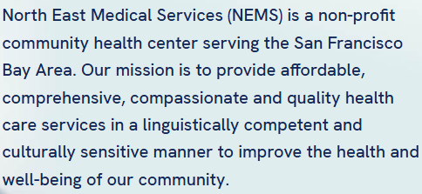

Open full-size image

## 52. SC-1.4.3 — color-contrast

Selector: .btn[href$="about-us/"][data-wahpro-txt-style="font-size: 20px;"]

Verdict: needs-change (confidence 0.7)

Reason: Computed contrast ratio for the link's text is unclear due to a background gradient, likely failing SC 1.4.3 thresholds.

Ref: https://dequeuniversity.com/rules/axe/4.7/color-contrast?application=axeAPI

Screenshot:



Open full-size image

## 53. SC-1.4.3 — color-contrast

Selector: .hs-intro > h2[data-wahpro-titles-style="font-size: 70px;"]

Verdict: needs-change (confidence 0.8)

Reason: Computed contrast for the heading 'Services' is below the required 3:1 for large text due to an undetermined background gradient.

Ref: https://dequeuniversity.com/rules/axe/4.7/color-contrast?application=axeAPI

Screenshot:



Open full-size image

## 54. SC-1.4.3 — color-contrast

Selector: .hs-intro > p

Verdict: needs-change (confidence 0.7)

Reason: Computed contrast ratio cannot be determined due to a background gradient, likely failing the 4.5:1 threshold for normal text.

Ref: https://dequeuniversity.com/rules/axe/4.7/color-contrast?application=axeAPI

Screenshot:



Open full-size image

## 55. SC-1.4.3 — color-contrast

Selector: .topcol-1 > .hsd-card[data-wahpro-txt-style="font-size: 20px;"] > .hsd-content > .hsd-title

Verdict: needs-change (confidence 0.7)

Reason: Computed contrast for the text 'Medical' cannot be determined due to a pseudo element, likely failing SC 1.4.3 thresholds.

Ref: https://dequeuniversity.com/rules/axe/4.7/color-contrast?application=axeAPI

Screenshot:



Open full-size image

## 56. SC-1.4.3 — color-contrast

Selector: .tc2-row1 > .hsd-card[data-wahpro-txt-style="font-size: 20px;"] > .hsd-content > .hsd-title

Verdict: needs-change (confidence 0.8)

Reason: Computed contrast for the text 'Dental' is below the required threshold due to undetermined background color from a pseudo element.

Ref: https://dequeuniversity.com/rules/axe/4.7/color-contrast?application=axeAPI

Screenshot:



Open full-size image

## 57. SC-1.4.3 — color-contrast

Selector: .tc2-row2 > .hsd-light.hsd-card[data-wahpro-txt-style="font-size: 20px;"] > .hsd-content > .hsd-title

Verdict: needs-change (confidence 0.8)

Reason: Computed contrast for 'Behavioral Health' is below 4.5:1 due to undetermined background color from a pseudo element.

Ref: https://dequeuniversity.com/rules/axe/4.7/color-contrast?application=axeAPI

Screenshot:



Open full-size image

## 58. SC-1.4.3 — color-contrast

Selector: .tc2-row2 > .hsd-card[data-wahpro-txt-style="font-size: 20px;"]:nth-child(2) > .hsd-content > .hsd-title

Verdict: needs-change (confidence 0.8)

Reason: Computed contrast for 'Optometry' is below the required threshold due to undetermined background color from a pseudo element.

Ref: https://dequeuniversity.com/rules/axe/4.7/color-contrast?application=axeAPI

Screenshot:



Open full-size image

## 59. SC-1.4.3 — color-contrast

Selector: .hsd-btmrow > .hsd-light.hsd-card[data-wahpro-txt-style="font-size: 20px;"]:nth-child(1) > .hsd-content > .hsd-title

Verdict: needs-change (confidence 0.7)

Reason: Computed contrast for 'Ancillary Services' is likely below 4.5:1 due to undetermined background color from a pseudo element, failing SC 1.4.3.

Ref: https://dequeuniversity.com/rules/axe/4.7/color-contrast?application=axeAPI

Screenshot:



Open full-size image

## 60. SC-1.4.3 — color-contrast

Selector: .hsd-light.hsd-card[data-wahpro-txt-style="font-size: 20px;"]:nth-child(2) > .hsd-content > .hsd-title

Verdict: needs-change (confidence 0.7)

Reason: Computed contrast for the text 'Integrative Medicine' is below the required threshold due to undetermined background color from a pseudo element.

Ref: https://dequeuniversity.com/rules/axe/4.7/color-contrast?application=axeAPI

Screenshot:



Open full-size image

## 61. SC-1.4.3 — color-contrast

Selector: .hl-intro > h2[data-wahpro-titles-style="font-size: 70px;"]

Verdict: needs-change (confidence 0.8)

Reason: Computed contrast for the text 'A Location Near You' cannot be determined due to a background gradient, likely failing SC 1.4.3.

Ref: https://dequeuniversity.com/rules/axe/4.7/color-contrast?application=axeAPI

Screenshot:



Open full-size image

## 62. SC-1.4.3 — color-contrast

Selector: .hl-intro > p

Verdict: needs-change (confidence 0.8)

Reason: Computed contrast ratio cannot be determined due to a background gradient, likely failing the 4.5:1 requirement for normal text.

Ref: https://dequeuniversity.com/rules/axe/4.7/color-contrast?application=axeAPI

Screenshot:



Open full-size image

## 63. SC-1.4.3 — color-contrast

Selector: a[data-tab="tab-sf"]

Verdict: needs-change (confidence 0.8)

Reason: Computed contrast ratio for the link 'San Francisco' could not be determined due to a background gradient, likely failing SC 1.4.3.

Ref: https://dequeuniversity.com/rules/axe/4.7/color-contrast?application=axeAPI

Screenshot:



Open full-size image

## 64. SC-1.4.3 — color-contrast

Selector: a[data-tab="tab-daly"]

Verdict: needs-change (confidence 0.8)

Reason: Computed contrast ratio cannot be determined due to a background gradient, likely failing SC 1.4.3 thresholds.

Ref: https://dequeuniversity.com/rules/axe/4.7/color-contrast?application=axeAPI

Screenshot:



Open full-size image

## 65. SC-1.4.3 — color-contrast

Selector: a[data-tab="tab-sj"]

Verdict: needs-change (confidence 0.8)

Reason: Computed contrast ratio cannot be determined due to a background gradient, likely failing SC 1.4.3 thresholds.

Ref: https://dequeuniversity.com/rules/axe/4.7/color-contrast?application=axeAPI

Screenshot:



Open full-size image

## 66. SC-1.4.3 — color-contrast

Selector: a[data-tab="tab-lv"]

Verdict: needs-change (confidence 0.8)

Reason: Computed contrast ratio cannot be determined due to a background gradient, likely failing SC 1.4.3 thresholds.

Ref: https://dequeuniversity.com/rules/axe/4.7/color-contrast?application=axeAPI

Screenshot:



Open full-size image

## 67. SC-1.4.3 — color-contrast

Selector: a[data-tab="tab-ssf"]

Verdict: needs-change (confidence 0.8)

Reason: Computed contrast ratio cannot be determined due to a background gradient, likely failing SC 1.4.3 thresholds.

Ref: https://dequeuniversity.com/rules/axe/4.7/color-contrast?application=axeAPI

Screenshot:



Open full-size image

## 68. SC-1.4.3 — color-contrast

Selector: .active.owl-item:nth-child(1) > .locitem.item > .locitem-inner > .lci-content > .lci-btns > .btn[data-wahpro-txt-style="font-size: 16px;"]

Verdict: needs-change (confidence 0.8)

Reason: Computed contrast ratio cannot be determined due to a background gradient, likely failing SC 1.4.3 thresholds.

Ref: https://dequeuniversity.com/rules/axe/4.7/color-contrast?application=axeAPI

Screenshot:



Open full-size image

## 69. SC-1.4.3 — color-contrast

Selector: .active.owl-item:nth-child(2) > .locitem.item > .locitem-inner > .lci-content > .lci-btns > .btn[data-wahpro-txt-style="font-size: 16px;"]

Verdict: needs-change (confidence 0.8)

Reason: Computed contrast for the link's text is likely below 4.5:1 due to an undetermined background gradient, as indicated by AXE diagnostics.

Ref: https://dequeuniversity.com/rules/axe/4.7/color-contrast?application=axeAPI

Screenshot:



Open full-size image

## 70. SC-1.4.3 — color-contrast

Selector: .active.owl-item:nth-child(3) > .locitem.item > .locitem-inner > .lci-content > .lci-btns > .btn[data-wahpro-txt-style="font-size: 16px;"]

Verdict: needs-change (confidence 0.8)

Reason: Computed contrast for the link 'More Info' cannot be determined due to a background gradient, likely failing SC 1.4.3.

Ref: https://dequeuniversity.com/rules/axe/4.7/color-contrast?application=axeAPI

Screenshot:



Open full-size image

## 71. SC-1.4.3 — color-contrast

Selector: .quotes-intro > h2[data-wahpro-titles-style="font-size: 70px;"]

Verdict: needs-change (confidence 0.8)

Reason: Computed contrast for the text 'What Our Members Say About Us' cannot be determined due to overlapping elements, likely failing SC 1.4.3.

Ref: https://dequeuniversity.com/rules/axe/4.7/color-contrast?application=axeAPI

Screenshot:



Open full-size image

## 72. SC-1.4.3 — color-contrast

Selector: .topbtn

Verdict: needs-change (confidence 0.8)

Reason: Computed contrast ratio cannot be determined due to a background gradient, likely failing SC 1.4.3 thresholds.

Ref: https://dequeuniversity.com/rules/axe/4.7/color-contrast?application=axeAPI

Screenshot:



Open full-size image

## 73. SC-1.4.3 — color-contrast

Selector: .btn[target="_blank"][data-wahpro-txt-style="font-size: 20px;"]:nth-child(2)

Verdict: needs-change (confidence 0.8)

Reason: Computed contrast ratio for the link's text is likely below 4.5:1 due to an undetermined background gradient, failing SC 1.4.3.

Ref: https://dequeuniversity.com/rules/axe/4.7/color-contrast?application=axeAPI

Screenshot:



Open full-size image

## 74. SC-1.4.3 — color-contrast

Selector: .fc-section:nth-child(2) > .footer-phone > .fp-numbers:nth-child(1) > a[href="tel:415-391-9686"][data-wahpro-txt-style="font-size: 20px;"]

Verdict: needs-change (confidence 0.8)

Reason: Computed contrast ratio for the link text '415-391-9686' is below the required 4.5:1 due to an undetermined background color from an image.

Ref: https://dequeuniversity.com/rules/axe/4.7/color-contrast?application=axeAPI

Screenshot:



Open full-size image

## 75. SC-1.4.3 — color-contrast

Selector: .fc-section:nth-child(2) > .footer-phone > .fp-numbers:nth-child(2) > a[href="tel:650-550-3923"][data-wahpro-txt-style="font-size: 20px;"]

Verdict: needs-change (confidence 0.8)

Reason: Computed contrast for the link text '650-550-3923' could not be determined due to a background image, likely failing SC 1.4.3.

Ref: https://dequeuniversity.com/rules/axe/4.7/color-contrast?application=axeAPI

Screenshot:



Open full-size image

## 76. SC-1.4.3 — color-contrast

Selector: .fc-section:nth-child(2) > .footer-phone > .fp-numbers:nth-child(3) > a[href="tel:408-573-9686"][data-wahpro-txt-style="font-size: 20px;"]

Verdict: needs-change (confidence 0.8)

Reason: Computed contrast for the link text '408-573-9686' cannot be determined due to a background image, likely failing SC 1.4.3.

Ref: https://dequeuniversity.com/rules/axe/4.7/color-contrast?application=axeAPI

Screenshot:



Open full-size image

## 77. SC-1.4.3 — color-contrast

Selector: .fc-section:nth-child(2) > .footer-phone > .fp-numbers:nth-child(4) > a[href="tel:702-589-9686"][data-wahpro-txt-style="font-size: 20px;"]

Verdict: needs-change (confidence 0.8)

Reason: Computed contrast for the link text '702-589-9686' is below the required threshold due to an undetermined background color from an image.

Ref: https://dequeuniversity.com/rules/axe/4.7/color-contrast?application=axeAPI

Screenshot:



Open full-size image

## 78. SC-1.1.1 — image-alt

Selector: .logo-img

Verdict: needs-change (confidence 0.8)

Reason: The alt text 'Logo' is vague and does not describe the link's destination or purpose, which is required for functional images.

Ref: https://dequeuniversity.com/rules/axe/4.7/image-alt?application=axeAPI

Screenshot:



Open full-size image

Embedded screenshots: 62 of 78